SECO Flexo Folder Gluer

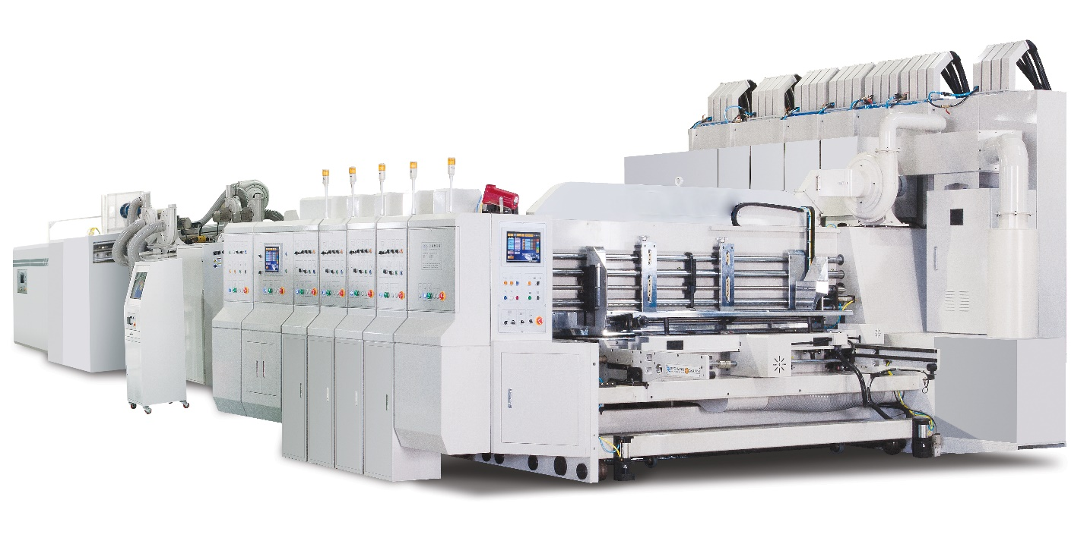
SECO MODEL | SIZE
924-FFG 2/C | 35” x 94”
1228-FFGD 2/C | 47” x 111”
1628-FPSD 2/C | 63” x 111”
1633-FFGD 2/C | 63" x 130"
1634-FFGD 2/C | 63" x 136"
1638-FFGD 2/C | 63" x 151
1644-FFGD 2/C | 63” x 173”
1650-FFG 2/C | 63” x 198”
2038-FFGD 2/C | 78" x 149"
2050-FFG 2/C | 78” x 198”
2350-FFG 2/C | 92” x 216”
2555-FFGD 2/C | 98” x 216”

